15U ENCLOSURE 19" CABINET 600X1000 15U SERVER RACK CABINET FLOOR STANDING
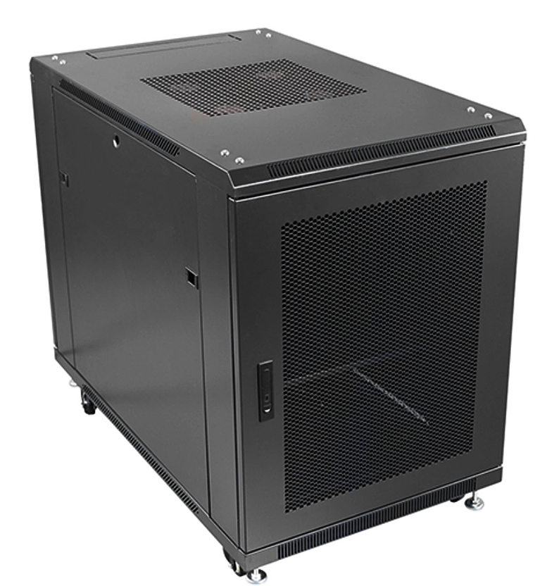

DESCRIPTION
Redefining quality compact ergonomics for server and networking
Looking to house your latest rack-mount Server, SAN, UPS and other
networking devices in a compact, universal server enclosure?
The new CAB-FE-15U-6100 is one of the most compact server enclosures on the
market today, but still has all the features IT integrators comes to expect from its
larger counterparts. Full 19-inch wide profiles, front and rear adjustable profile
design with a thicker gauge design to carry the extra weight of a fully populated
server, UPS or other electronic networking device.
Complementing the design is the industry standard, 1000mm depth to
facilitate almost all servers with the extra benefit of increased airflow. This has been
further enhanced with the integral front meshed door to allow ambient air to
circulate correctly and thus reduce server downtime. As with LMS Data enclosures, a
fitted roof fan-tray provides effective removal of warm air from the enclosure
and thus the LMS Data compact server enclosures is your ideal choice for mission
critical applications - big or small.

SPECIFICATIONS
- ETSI 19” front/rear profiles (adjustable)
- Universal server design for all popular servers, UPS, SAN & more*
- Up to 800Kg static load bearing
- Front mesh high venting door (lockable)
- Left/right hinged front/rear doors
- Removable side panels for easy access
- U-numbered uprights for rack-mount product alignment
- Multiple cable entry glands for exact power and cabling entry
- Fitted 4-way fan tray in raised and vented roof-space
- Fitted vented shelf
- Powder-coated RAL 9005 finish

TECHNICAL INFO
SKU/MPN: CAB-FE-15U-6100
EAN: 8400800025319
Weight: 50kg
Dimensions: 600x1000x860mm

FILES
Datasheet - CAB-FE-15U-6100

